UNITED STATES
SECURITIES AND EXCHANGE COMMISSION
Washington, D.C. 20549

SCHEDULE 14A
(Rule 14a-101)

INFORMATION REQUIRED IN PROXY STATEMENT

SCHEDULE 14A INFORMATION

Proxy Statement Pursuant to Section 14(a) of
the Securities Exchange Act of 1934 (Amendment No. )

Filed by the Registrant ☒

Filed by a Party other than the Registrant ☐

Check the appropriate box:

☐ | Preliminary Proxy Statement

☐ | Confidential, for Use of the Commission Only (as permitted by Rule 14a-6(e)(2))

☐ | Definitive Proxy Statement

☒ | Definitive Additional Materials

☐ | Soliciting Material under §240.14a-12

FS Specialty Lending Fund
(Name of Registrant as Specified in its Charter)

(Name of Person(s) Filing Proxy Statement, if other than the Registrant)

Payment of Filing Fee (Check the appropriate box):

☒ | No fee required.
☐ | Fee paid previously with preliminary materials.
☐ | Fee computed on table in exhibit required by Item 25(b) per Exchange Act Rules 14a-6(i)(1) and 0-11.

 | 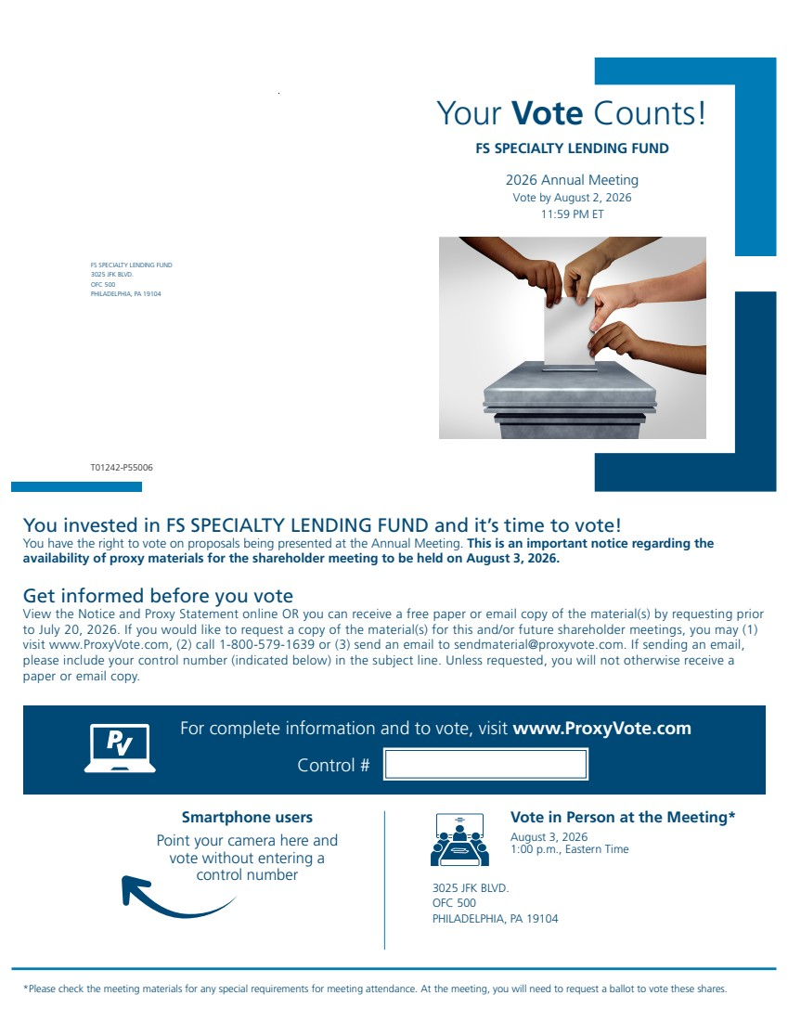 | Your Vote Counts! FS SPECIALTY LENDING FUND 3025 JFK BLVD. OFC 500 PHILADELPHIA, PA 19104 FS SPECIALTY LENDING FUND 2026 Annual Meeting Vote by August 2, 2026 11:59 PM ET Vote in Person at the Meeting* August 3, 2026 1:00 p.m., Eastern Time 3025 JFK BLVD. OFC 500 PHILADELPHIA, PA 19104 *Please check the meeting materials for any special requirements for meeting attendance. At the meeting, you will need to request a ballot to vote these shares. Smartphone users Point your camera here and vote without entering a control number For complete information and to vote, visit www.ProxyVote.com Control # T01242-P55006 You invested in FS SPECIALTY LENDING FUND and it’s time to vote! You have the right to vote on proposals being presented at the Annual Meeting. This is an important notice regarding the availability of proxy materials for the shareholder meeting to be held on August 3, 2026. Get informed before you vote View the Notice and Proxy Statement online OR you can receive a free paper or email copy of the material(s) by requesting prior to July 20, 2026. If you would like to request a copy of the material(s) for this and/or future shareholder meetings, you may (1) visit www.ProxyVote.com, (2) call 1-800-579-1639 or (3) send an email to sendmaterial@proxyvote.com. If sending an email, please include your control number (indicated below) in the subject line. Unless requested, you will not otherwise receive a paper or email copy.
 | 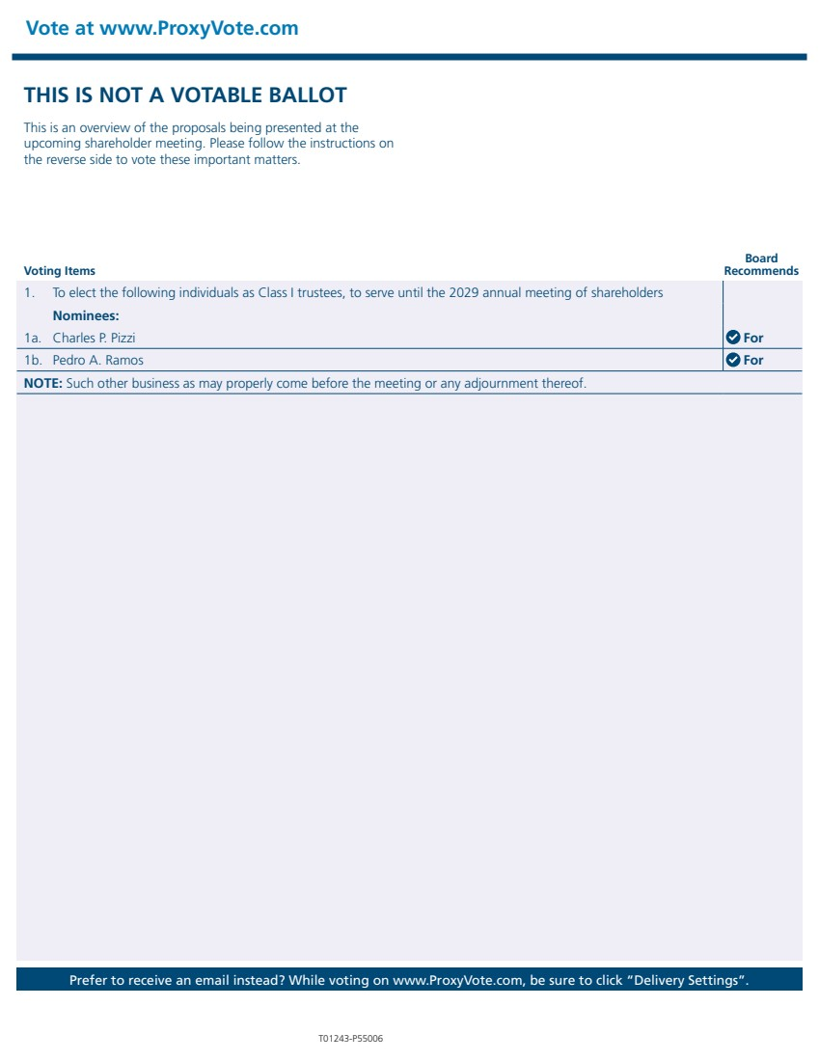 | THIS IS NOT A VOTABLE BALLOT This is an overview of the proposals being presented at the upcoming shareholder meeting. Please follow the instructions on the reverse side to vote these important matters. Vote at www.ProxyVote.com Prefer to receive an email instead? While voting on www.ProxyVote.com, be sure to click “Delivery Settings”. T01243-P55006 Voting Items Board Recommends 1. To elect the following individuals as Class I trustees, to serve until the 2029 annual meeting of shareholders Nominees: 1a. Charles P. Pizzi For 1b. Pedro A. Ramos For NOTE: Such other business as may properly come before the meeting or any adjournment thereof.

