UNITED STATES
SECURITIES AND EXCHANGE COMMISSION
Washington, D.C. 20549

SCHEDULE 14A
(Rule 14a-101)

INFORMATION REQUIRED IN PROXY STATEMENT

SCHEDULE 14A INFORMATION

Proxy Statement Pursuant to Section 14(a) of
the Securities Exchange Act of 1934

Filed by the Registrant ☒

Filed by a Party other than the Registrant ☐

Check the appropriate box:

☐ | Preliminary Proxy Statement
☐ | Confidential, for Use of the Commission Only (as permitted by Rule 14a-6(e)(2))
☐ | Definitive Proxy Statement
☒ | Definitive Additional Materials
☐ | Soliciting Material under §240.14a-12

FS Specialty Lending Fund
(Name of Registrant as Specified in its Charter)

(Name of Person(s) Filing Proxy Statement, if other than the Registrant)

Payment of Filing Fee (Check the appropriate box):

☒ | No fee required.
☐ | Fee paid previously with preliminary materials.
☐ | Fee computed on table in exhibit required by Item 25(b) per Exchange Act Rules 14a-6(i)(1) and 0-11.

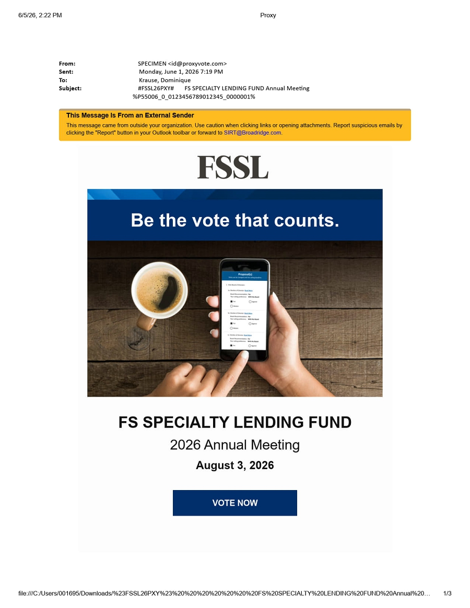 | This Message Is From an External Sender This message came from outside your organization. Use caution when clicking links or opening attachments. Report suspicious emails by clicking the "Report" button in your Outlook toolbar or forward to SIRT@Broadridge.com.From: SPECIMEN <id@proxyvote.com> Sent: Monday, June 1, 2026 7:19 PM To: Krause, Dominique Subject: #FSSL26PXY# FS SPECIALTY LENDING FUND Annual Meeting %P55006_0_0123456789012345_0000001%Be the vote that counts.FS SPECIALTY LENDING FUND 2026 Annual Meeting August 3, 2026VOTE NOW6/5/26, 2:22 PM Proxyfile:///C:/Users/001695/Downloads/%23FSSL26PXY%23%20%20%20%20%20%20%20FS%20SPECIALTY%20LENDING%20FUND%20Annual%20… 1/3

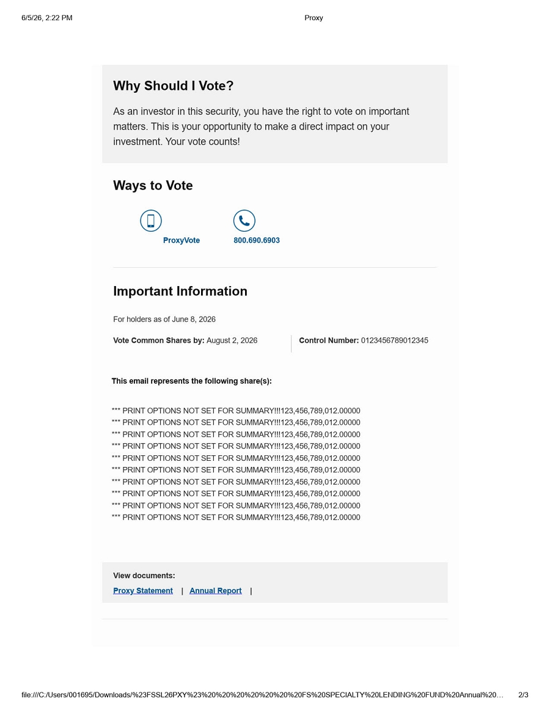 | This email represents the following share(s):*** PRINT OPTIONS NOT SET FOR SUMMARY!!!123,456,789,012.00000 *** PRINT OPTIONS NOT SET FOR SUMMARY!!!123,456,789,012.00000 *** PRINT OPTIONS NOT SET FOR SUMMARY!!!123,456,789,012.00000 *** PRINT OPTIONS NOT SET FOR SUMMARY!!!123,456,789,012.00000 *** PRINT OPTIONS NOT SET FOR SUMMARY!!!123,456,789,012.00000 *** PRINT OPTIONS NOT SET FOR SUMMARY!!!123,456,789,012.00000 *** PRINT OPTIONS NOT SET FOR SUMMARY!!!123,456,789,012.00000 *** PRINT OPTIONS NOT SET FOR SUMMARY!!!123,456,789,012.00000 *** PRINT OPTIONS NOT SET FOR SUMMARY!!!123,456,789,012.00000 *** PRINT OPTIONS NOT SET FOR SUMMARY!!!123,456,789,012.00000Proxy Statement | Annual Report |Why Should I Vote? As an investor in this security, you have the right to vote on important matters. This is your opportunity to make a direct impact on your investment. Your vote counts!Ways to VoteProxyVote 800.690.6903Important Information For holders as of June 8, 2026Vote Common Shares by: August 2, 2026 Control Number: 0123456789012345View documents:6/5/26, 2:22 PM Proxyfile:///C:/Users/001695/Downloads/%23FSSL26PXY%23%20%20%20%20%20%20%20FS%20SPECIALTY%20LENDING%20FUND%20Annual%20… 2/3

 | © 2026 Broadridge Financial Solutions Inc. P.O. Box 1310, Brentwood, NY 11717 ProxyVote and Broadridge are trademarks of Broadridge Financial Solutions Inc. CUSIP is a registered trademark of the American Bankers Association. All other registered marks belong to their respective owners. Email Settings | Terms and Conditions | Privacy Statement6/5/26, 2:22 PM Proxyfile:///C:/Users/001695/Downloads/%23FSSL26PXY%23%20%20%20%20%20%20%20FS%20SPECIALTY%20LENDING%20FUND%20Annual%20… 3/3

